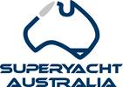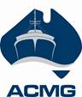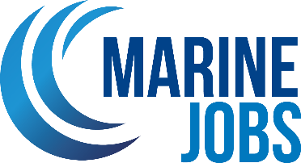

Media Release

FOR IMMEDIATE RELEASE 1 May 2024

CAIRNS MARITIME JOBS & CAREERS EXPO 2024
SHOWCASING LOCAL JOBS AND GLOBAL OPPORTUNITIES

Hosted by the Australian International Marine Export Group at the Cairns Cruising Yacht Squadron
Cairns, QLD – The Portsmith Marine Precinct will come alive as The Australian International Marine Export Group (AIMEX) and Marine Jobs proudly present the Cairns Maritime Jobs & Careers Expo 2024. This free to attend event stands as a pivotal platform for showcasing the expansive range of career opportunities within the maritime sector and will take on Saturday, 8 June 2024, from 9:00am to 2:00pm at the Cairns Cruising Yacht Squadron.
This year’s expo is enhanced by exclusive on-water experiences and industry tours, providing attendees with an in-depth look at the maritime industry’s vibrant scope. Notable activities include tours provided by Shoreline and Mandingalbay Authentic Indigenous Tours which will embark from the Cairns Cruising Yacht Squadron Marina and take attendees around Admiralty Island and into Trinity Inlet. In addition, international shipping company Svitzer will provide a unique chance for direct conversations with their engineers as tours above and below deck take place on a range of vessels.
These experiences, along with industry tours offered by our location partners such as Norship, Austal, Seaswift, North Marine, Tropical Reef Shipyard and the TAFE Queensland - Great Barrier Reef International Marine College, aim to immerse participants in the real-world experiences of the maritime industry.
“We are thrilled to host the Cairns Maritime Jobs & Careers Expo and provide industry with the opportunity to showcase the exciting career opportunities available in the maritime industry,” said David Good, CEO of AIMEX. “We hope to inspire and educate the next generation of skilled maritime workers to support and grow the industry.”
Delivered by industry leaders and experts, the event will also feature focused panel discussions and presentations covering topics such as the tertiary level engineering roles required for the region’s future workforce, entry level positions and pathways, trade apprenticeships, women in maritime, defence industry pathways, superyacht opportunities, and the immediate employment needs for our tourism sector.
Central to the expo, an interactive jobs board will directly connect job seekers with vacancies, highlighting the variety of roles available within the industry, from operational and technical positions to careers in diving.
Generously supported by our sponsors and partners, which include Jobs Queensland, Workforce Australia – Local Jobs Committee, Regional Jobs Committee, Department of Employment, Small Business and Training, Cairns Manufacturing Hub, TAFE Queensland, Department of State Development and Infrastructure, Shoreline, universities and training organisations, the Cairns Maritime Jobs & Careers Expo 2024 facilitates valuable networking opportunities and insights into the maritime industry’s significant economic contributions.
We extend an invitation to job seekers, high school students, transitioning Defence Personnel, university students, and those contemplating a career shift, to explore the myriad of possibilities the marine and maritime industry has to offer.
Event Details:
- Date: Saturday, 8 June 2024
- Time: 9:00 AM to 2:00 PM
- Location: Cairns Cruising Yacht Squadron
This event free and open to the public - Take this chance to reshape your understanding of what a career within the marine and maritime industry looks like by attending the Cairns Maritime Jobs & Careers Expo 2024.
Explore event information here
Attendees are encouraged to register online to secure their place here
Businesses are encouraged to register their EOI online here
<Ends>

Explore full image library here
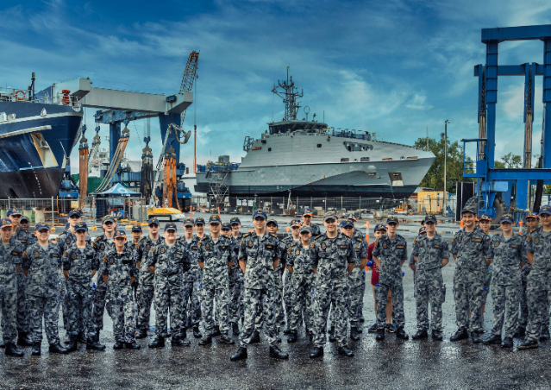 | Navy Cadets attending the 2023 Cairns Maritime Expo
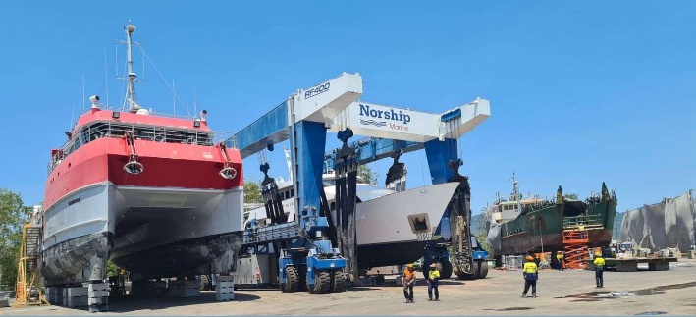 | Industry partner Norship
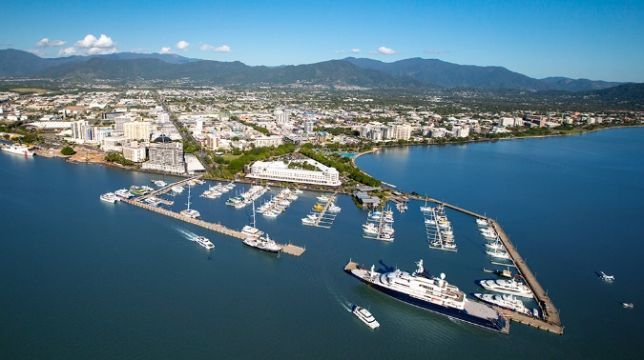 | Cairns Marlin Marina
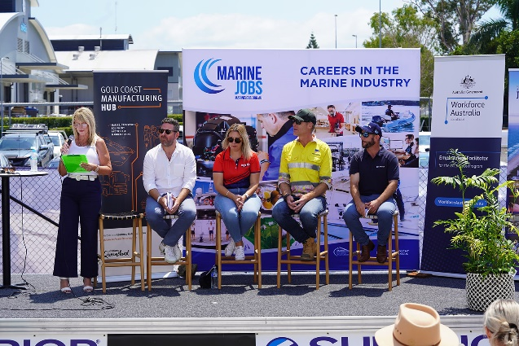 | Information session from a previous careers event

FOR MORE INFORMATION, CONTACT:
Adam Chanter
Maritime Industry Skills Advisor, Marine Jobs
Mob: +61 (0) 432 600 233
Email: achanter@aimex.asn.au

FOR MEDIA INFORMATION, CONTACT:
David Good
Chief Executive Officer, AIMEX, Superyacht Australia and ACMG
Mob: +61 (0) 413 375 820
Email: dgood@aimex.asn.au

About Marine Jobs
Marine Jobs is a ‘career centre’ dedicated to the marinas and boating industry and is a collaboration between the Marina Industries Association (MIA), the Boating Industry Association (BIA) and Superyacht Australia to improve the efficiency and effectiveness of recruitment processes for employers and increase industry employee retention.
Its primary purpose is a recruitment platform where employers can post jobs to a qualified and targeted job seeker market, but Marine Jobs also provides a range of career resources, including information on apprenticeships and industry training.
About AIMEX:
The Australian International Marine Export Group (AIMEX) is the peak body for the marine export industry. The objective of AIMEX is to develop and promote Australia's international competitiveness in the marine sector. AIMEX represents some of Australia's most successful international brands, emerging companies and firms that showcase exciting innovation and technological development.
About Superyacht Australia:
Superyacht Australia is the peak body for the Australian Superyacht Industry. Our key focus is to develop and promote Australia's international competitiveness as a destination for the global superyacht fleet, to increase visitations of superyachts to Australia and to promote the capabilities of the Australian superyacht industry to service a visiting vessel’s every need.
About Australian Commercial Marine Group:
The Australian Commercial Marine Group (ACMG), created under the AIMEX and Superyacht Australia umbrella is the leading industry body supporting, developing and promoting the Australian Commercial and Defence Maritime Industry both nationally and internationally.

