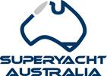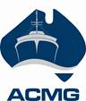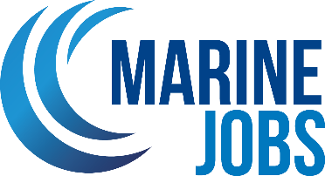

Media Release

FOR IMMEDIATE RELEASE 11 June 2024

CAIRNS MARITIME JOBS & CAREERS EXPO 2024 LAUNCHES NEW REGIONAL WORKFORCE PLAN
In collaboration with local industry and government departments the Australian International Marine Export Group hosted the second annual Cairns Maritime Jobs and Careers Expo on Saturday, June 8, 2024. This free to attend event, held at the Cairns Cruising Yacht Squadron offered attendees the chance to explore various locations throughout the precinct, including Austal, Norship, Tropical Reef Shipyard and the Great Barrier Reef International Marine College.
Reinforcing its status as a pivotal event in the maritime sector, the event offered an invaluable platform for networking, career exploration and industry insight, surpassing last year’s attendance records to garner the attention of 1269 participants.
The official opening to the days events was delivered by the Minister for Tourism and Sport Michael Healy MP, whereby the Cairns Region Workforce Development Plan which highlights Marine and Maritime workforce capability was launched.
Andrew Hayes Enterprise Development Manager of NORSTA Maritime – RMP North East was the event Master of Ceremonies who delivered valuable insights into the future developments within the Cairns Maritime industry, whilst introducing panellists for the six information sessions, which included: Hastings Deering (CAT) | Rob Owen, Manager of Energy and Transport Sally McAuliffe, Commander, Marine Deployments; Tropical Reef Shipyard | Dylann Chapman, QLD Marine Apprentice of the Year 2024; Seaswift | Jesse Lee, Fleet Manager and James Cook University | Nico Adams, Associate Dean, Industry and Innovation within the College of Science & Engineering to name but a few.
The event attracted a diverse group of attendees, including job seekers, individuals considering a career change, transitioning defence personnel, families seeking inspiration for the next career opportunity, high school and university students, and others, including career advisors from as far south as Brisbane travelling to gather information on the unique opportunities available within the Cairns maritime community for their out of region networks.
The Cairns Cruising Yacht Squadron, serving as the main hub for the event, highlighted the extensive range of career opportunities within the Cairns maritime sector. Attendees gained valuable industry insights through live presentations on apprenticeships, defence and superyacht careers, advanced manufacturing, women in maritime and pathways to a maritime career.
Additionally, the live jobs board was a hive of activity connecting attendees with thirty-five local marine industry employers exhibiting on the day.
A highlight of the event was the opportunity to experience the maritime industry firsthand through shipyard tours in the Portsmith Marine Precinct. Attendees were able to get an up-close look at the 39 metre Roebuck Bay Australian Border Force vessel, a Svitzer tugboat, the TAFE Queensland “Diversity” vessel and enjoy the Mandingalbay Authentic Indigenous Tours around Admiralty Island and into Trinity Inlet.
Commander Sally McAuliffe said “The Australian Border Force was delighted to be involved the Cairns Maritime Jobs and Careers Expo. More than 200 people visited our vessel Roebuck Bay, our stand ashore was very popular, and it was great to participate in the Women in Maritime and Pathways to a Maritime Career panel discussion. We were really pleased to be able to showcase the maritime career opportunities that the Australian Border Force has to offer. The Expo also provided us with an excellent opportunity to engage with the community, which is always a treat.”
Having the Svitzer tugboat available for participants to go below deck allowed for the full breadth of career pathways to be on activated on the day. Daniel Wade, Port Manager, Svitzer FNQ commented; “Svitzer Australia was delighted to both sponsor and participate in the 2024 Cairns Maritime Jobs and Career Expo. The event was a fantastic opportunity for Svitzer to showcase the towage work we do in the Far North Queensland Port of Cairns and the integral role we play in the local maritime industry. Our local Cairns tug crew were delighted to provide tugboat tours as part of the event, connecting with members of the Cairns community, maritime stakeholders, and inspiring the next generation of seafarers. At Svitzer we relished the opportunity to participate in the Expo and look forward to doing it again next year!”
David Good, CEO of AIMEX commented; “The Cairns Maritime Jobs & Careers Expo has become the largest of these events we run in Australia, proving how important the maritime industry is too Far North Queensland. With the Cairns Marine Precinct and Common User Facility project underway, Cairns will become a major marine skills base. Events such as these that attract talent to maritime careers will be vital to ensure these new facilities have skilled workers to operate them.”
The event was made possible through the generous long term support and dedication by each of our sponsors and partners, including; Cairns Cruising Yacht Squadron, Department of State Development & Infrastructure, Cairns Regional Jobs Committee, Department of Employment, Small Business and Training, Norsta Maritime, Workforce Australia, Regional Development Australia Tropical North, TAFE Queensland - Great Barrier Reef International Marine College, Jobs Queensland, Cairns Chamber of Commerce, Cairns Manufacturing Hub, Norship, Australian Border Force, Svitzer Australia, Austal, Tropical Reef Shipyard, Hastings Deering (Caterpillar), Pacific Marine Group, Bad Fishy Jet Boating, Mandingalbay Authentic Indigenous Tours, Superyacht Australia, Australian Marine Export Group (AIMEX) and the Australian Commercial Marine Group.
<Ends>

View the Cairns Region Workforce Development Plan here
Ministerial media announcement here
Explore full image library here

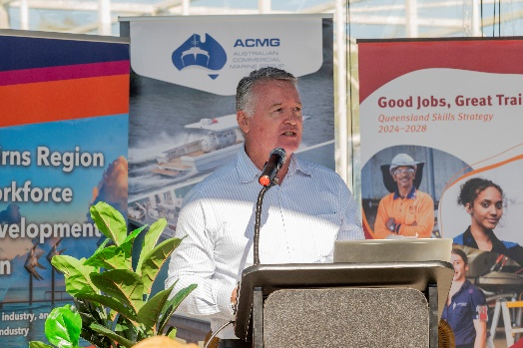 | Minister Michael Healy opening the 2024 Cairns Maritime Jobs & Careers Expo
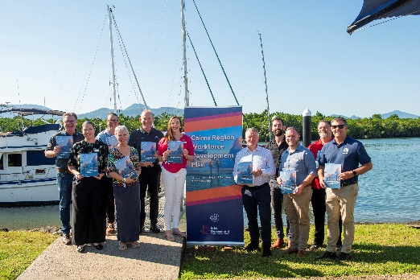 | Minister Michael Healy and the Project Champion Group launching the Jobs Queensland regional workforce plan
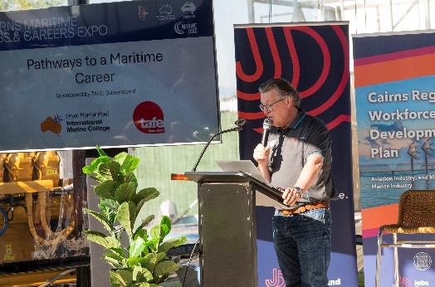 | Master of Ceremonies  Andrew Hayes Enterprise Development Manager of NORSTA Maritime – RMP North East
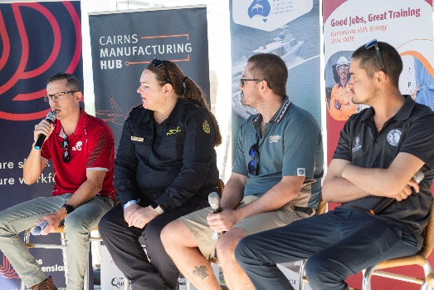 | Pathways to a maritime career panel discussion  (from left to right)  - TAFE Queensland | Richard Galeano (Business Manager)  - Australian Border Force | Sally McAuliffe (Commander, Marine Deployments and Support)  - Great Barrier Reef & Marine Parks | Callum Teale-Browne (Senior Ranger)  - TCS Shipwrights | Levi Colefax-Simmons (Team Leader)

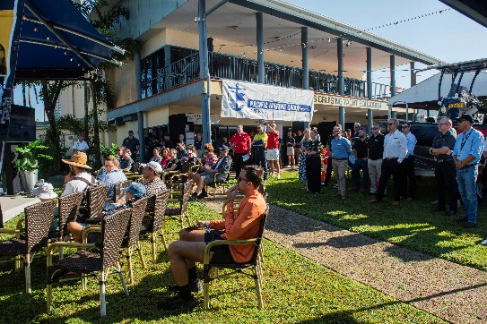 | Attendees at the 2024 Cairns Maritime Careers & Jobs Expo
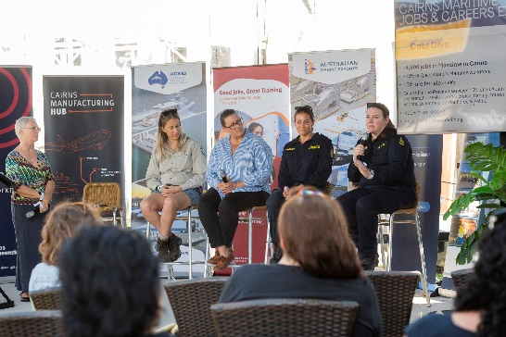 | Women in Maritime panel discussion  (from left to right)  - Workforce Australia – Local Jobs Program | Tamilyn Brennan  - Great Barrier Reef & Marine Parks | Tayce Cook | Marine Parks Ranger  - North Marine | Coutrney Hansen | Managing Director  - Australian Border Force | Rachel Presser | Marine Tactical Officer  - Australian Border Force | Sally McAuliffe |Commander, Marine Deployments
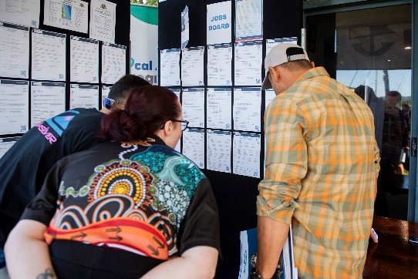 | 2024 Cairns Maritime Careers & Jobs Expo - Jobs Board
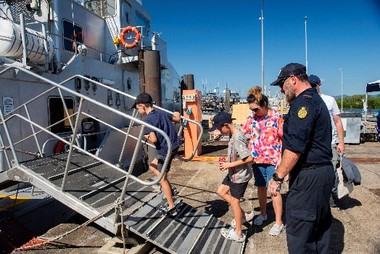 | 2024 Cairns Maritime Careers & Jobs Expo - Border Force tour

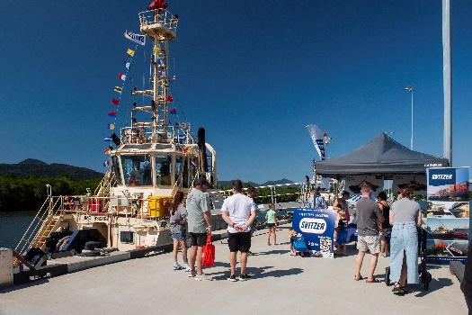 | 2024 Cairns Maritime Careers & Jobs Expo - Svitzer tour

FOR MORE INFORMATION, CONTACT:
Adam Chanter
Maritime Industry Skills Advisor, Marine Jobs
Mob: +61 (0) 432 600 233
Email: achanter@aimex.asn.au

FOR MEDIA INFORMATION, CONTACT:
David Good
Chief Executive Officer, AIMEX, Superyacht Australia and ACMG
Mob: +61 (0) 413 375 820
Email: dgood@aimex.asn.au

About Marine Jobs
Marine Jobs is a ‘career centre’ dedicated to the marinas and boating industry and is a collaboration between the Marina Industries Association (MIA), the Boating Industry Association (BIA) and Superyacht Australia to improve the efficiency and effectiveness of recruitment processes for employers and increase industry employee retention.
Its primary purpose is a recruitment platform where employers can post jobs to a qualified and targeted job seeker market, but Marine Jobs also provides a range of career resources, including information on apprenticeships and industry training.
About AIMEX:
The Australian International Marine Export Group (AIMEX) is the peak body for the marine export industry. The objective of AIMEX is to develop and promote Australia's international competitiveness in the marine sector. AIMEX represents some of Australia's most successful international brands, emerging companies and firms that showcase exciting innovation and technological development.
About Superyacht Australia:
Superyacht Australia is the peak body for the Australian Superyacht Industry. Our key focus is to develop and promote Australia's international competitiveness as a destination for the global superyacht fleet, to increase visitations of superyachts to Australia and to promote the capabilities of the Australian superyacht industry to service a visiting vessel’s every need.
About Australian Commercial Marine Group:
The Australian Commercial Marine Group (ACMG), created under the AIMEX and Superyacht Australia umbrella is the leading industry body supporting, developing and promoting the Australian Commercial and Defence Maritime Industry both nationally and internationally.

